  - A CHALLENGE WITHIN A CHALLENGE - by Iain Bartholomew, GWC’s top fundraiser
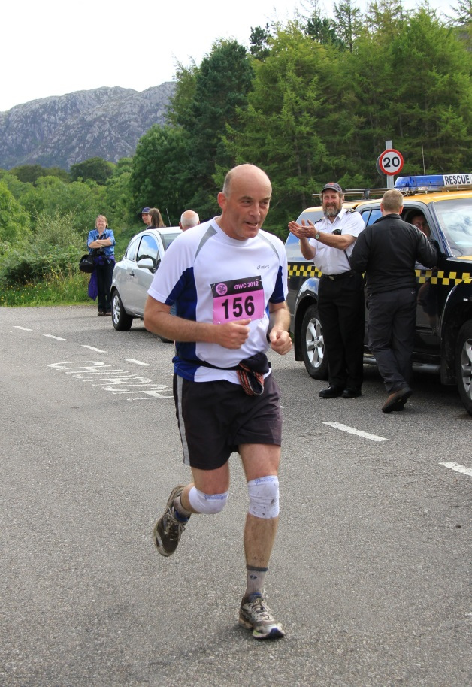
It has been a real honour to have been able to take part in the GWC for the last 12 years. Raising money on a regular basis is not easy. Once or twice would be fine but having to ask people for sponsorship year after year is hard! The key to success is the GWC event itself: raising money primarily for locally based medically related Scottish charities means so much to so many people. Unfortunately almost all of us have close family or friends who have suffered from cancer.
The most important thing for me to raising a consistent amount of money is to make sure your potential sponsor knows that you are really going to challenge yourself! I can assure everybody that I am no athlete and I have only admiration for those true athletes amongst us who complete the 25 miles in under 3 hours! The challenge for me is to keep fit enough during the year in order to just complete the course: but that's not good enough when trying raise major amounts of money! So what I do is ask a potential sponsor to pledge whatever they like for me to complete the 25 miles. I then ask them to agree to give me 50% more sponsorship if I manage to complete the 25 miles in under 5 hours: this may not sound much but I think that those that have run or walked the route understand! This is my challenge within a challenge.
I only started long distance running at the age of 40 when I was made redundant from my job whilst living in the USA. I had enough time then to reflect on trying to make myself a bit fitter but also how lucky I was to live in the UK and to take for granted so many things that a lot of people in the world just can't afford. Having already spent 10 years in Aultbea for many holidays and seeing a group of runners start off on the 13 mile run from Aultbea to Poolewe, I said to myself that I had better get off my backside and join them! ...and I have never looked back.
I find the GWC is one of the most inspiring things that I do in my busy life. Firstly the spirit of the people: the fact that so many people are involved and that the event is run in such a low key way makes it very special. I have never felt under any pressure to do anything more than turn up and run for good causes. It's a great feeling to see the same people year after year - not for a big chat, as I'm a shy kind of person, but a nod of the head, or a smile from somebody has a huge amount of significance. It's also a real family event with several members of my family taking part each year. Secondly the amazing scenery that we run through. As a geologist I truly appreciate what wonderful rock formations that we are running over. Does everybody realise that the race starts at a very important geological feature called the Moine Thrust and that some of the rocks that we run over are over 1 billion years old?
It makes me immensely proud when I am up in the Aultbea area to see a bus drive past which has been partly funded by the GWC and that I may have helped to hopefully make somebody's life a little easier. As the years go on I may have to increase my target time - but I hope to keep raising money for all the great causes that the GWC supports for many years to come and to enjoying the whole spirit of the event. I'd like to end with a big thank-you to all those involved in helping run the GWC year-on-year. Without you I would never have been motivated to do this!
Up to and including 2013, Iain has to raised £55,008 for GWC charities!!

